**AlphaNaut-Smart Helmet**

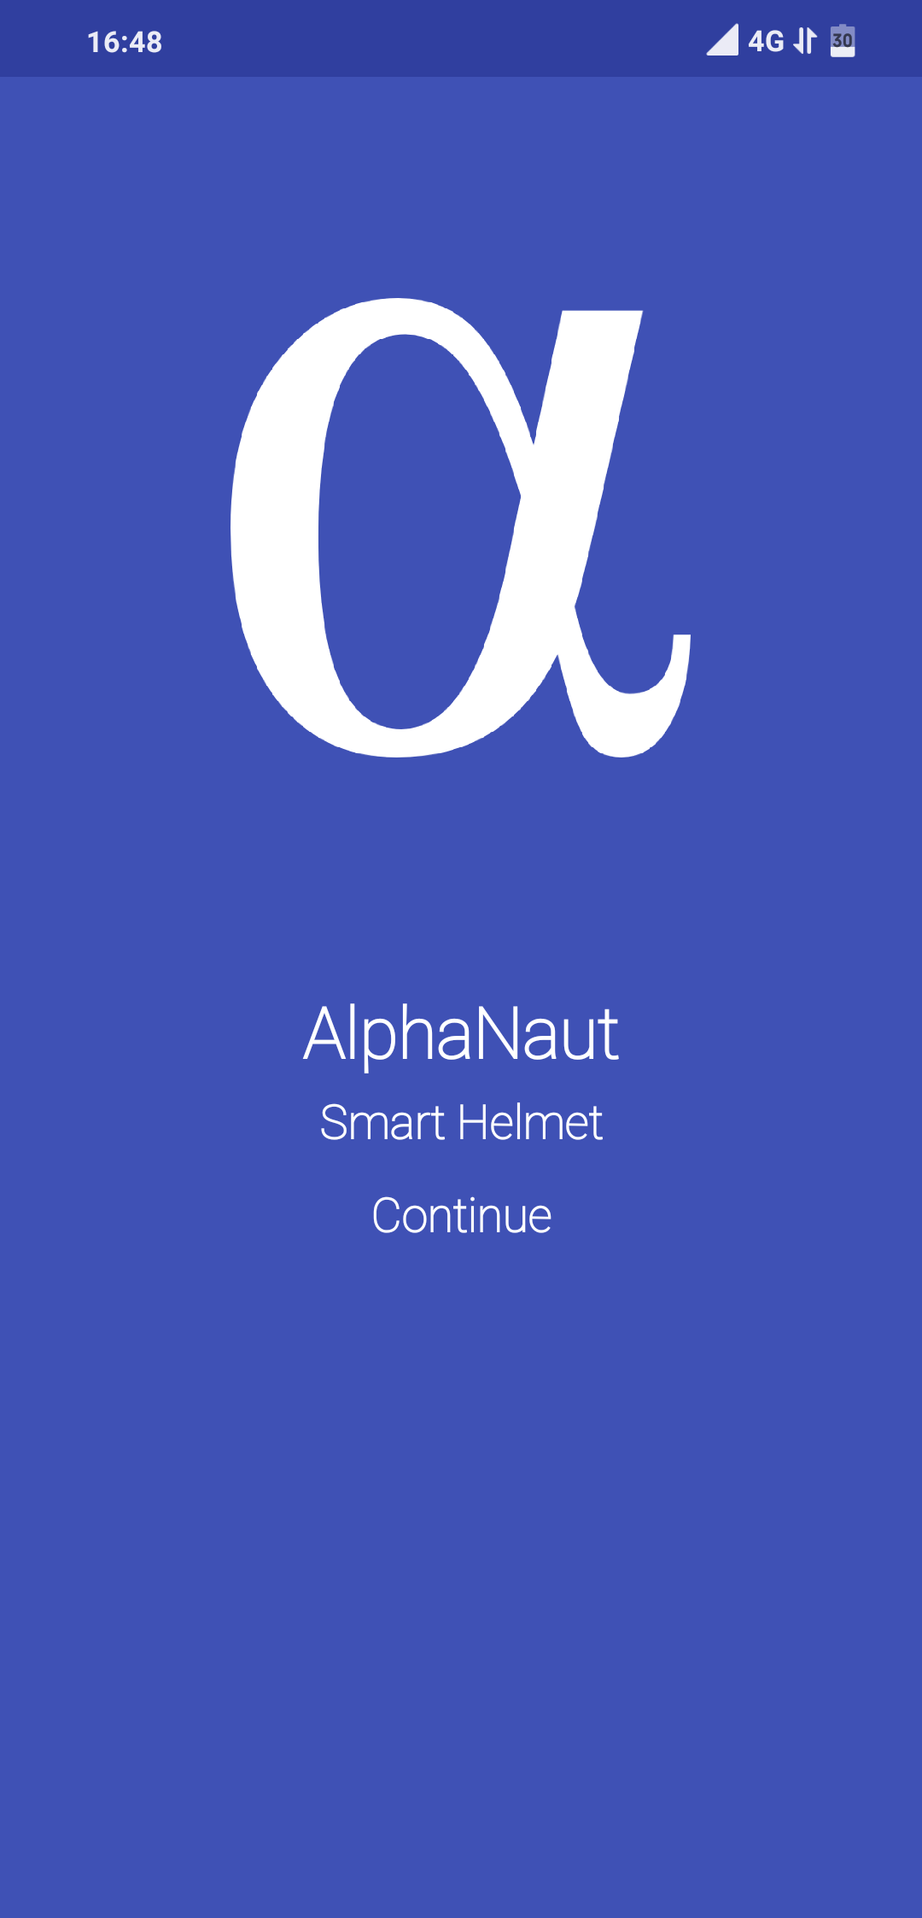

**Introduction**

AlphaNaut is a smart helmet , aimed to provide comfort and personal safety while driving two wheelers. The helmet is also connected to internet making it IOT device it is controlled and managed by an android app.

**Features**

Features of app are as follows:

1. Live Speed, Distance and Petrol consumption tracking
2. Helmet position and Ring the helmet if lost
3. Accident and Overspeed Detection
4. SOS Alert
5. Bike Mode
6. Alcohol Detection
7. Google Navigation

**Software and API’s Used**

1. Thunkable: App creator
2. Google Map API
3. LocationMagic Services
4. Raspberry Pi Zero W

**APP Workflow:**

Basic workflow is shown below

